**Assignment 7**

**Control Structure**

**If,else,elif:**

letter = "A"  
if letter == "B":  
 print("letter is B")  
elif letter == "C":  
 print("letter is C")  
else:  
 print("letter isn't A, B or C")

**Output:**

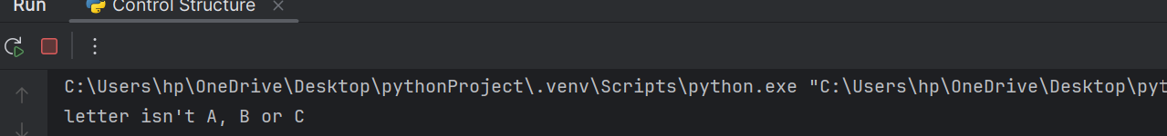

**For loop:**

for i in range(1, 8):  
 if i % 2 == 0:  
 print(f"{i} is an even number.")  
 else:  
 print(f"{i} is an odd number.")

**Output:**

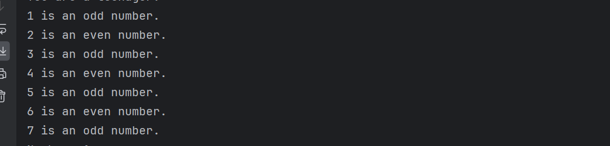

**While loop:**

counter = 1  
while counter <= 5:  
 print("Number:", counter)  
 counter += 1

**Output:**

**Nested Loop:**

for i in range(3):  
 for j in range(5):  
 print(f"({i}, {j})", end=" ")  
 print()

**Output:**

**Break,Continue,Pass:**

for i in range(1, 11):  
 if i % 2 == 0:  
 print(f"Even number: {i}")  
 continue  
 elif i == 7:  
 print("Breaking the loop at 7")  
 break  
 else:  
 pass  
  
 print(f"Number: {i}")  
print("Loop finished.")

**Output:**

**Lists And It’s Methods:**

my_list = [1, 2, 3, 4, 5]  
print("First element:", my_list[0])  
my_list[2] = 10  
print("Modified list:", my_list)  
my_list.append(6)  
print("List after appending:", my_list)  
my_list.remove(4)  
print("List after removing 4:", my_list)  
print("Length of the list:", len(my_list))  
my_list.insert(1, 5)  
print(my_list)  
popped_value = my_list.pop(1)  
print(my_list)  
print(popped_value)  
print("List elements:")  
for item in my_list:  
 print(item)

**Output:**

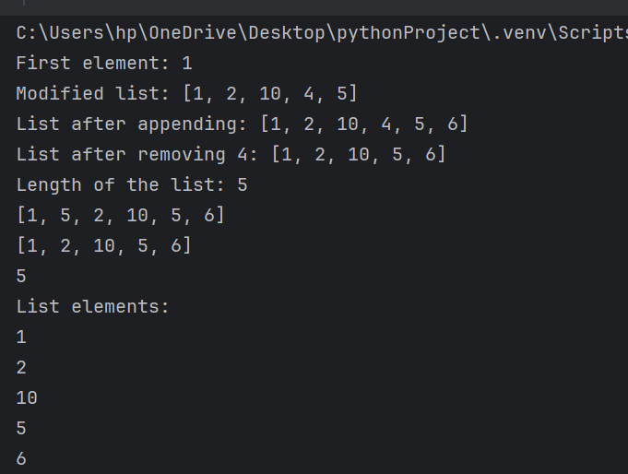

**Slicing:**

mylist = [1, 2, 3, 4, 5,6]  
sublist = mylist[1:4]  
print(sublist)  
sublist_with_step = mylist[::2]  
print(sublist_with_step)  
last_two_elements = mylist[-2:]  
print(last_two_elements)

**Output:**

**Dictionary:**

my_dict = {"name": "John", "age": 25, "city": "New York"}  
print("Name:", my_dict["name"])  
print("Age:", my_dict["age"])  
my_dict["age"] = 26  
print("Updated age:", my_dict["age"])  
my_dict["occupation"] = "Engineer"  
print("Updated dictionary:", my_dict)  
del my_dict["city"]  
print("Dictionary after removing 'city':", my_dict)  
  
if "city" in my_dict:  
 print("City:", my_dict["city"])  
else:  
 print("City not found in the dictionary.")  
keys = my_dict.keys()  
print("Keys:", keys)  
values = my_dict.values()  
print("Values:", values)  
items = my_dict.items()  
print("Items:", items)  
occupation = my_dict.pop("occupation")  
print("Removed occupation:", occupation)  
print("Updated dictionary:", my_dict)  
new_data = {"country": "USA", "age": 27}  
my_dict.update(new_data)  
print("Updated dictionary:", my_dict)

**Output:**

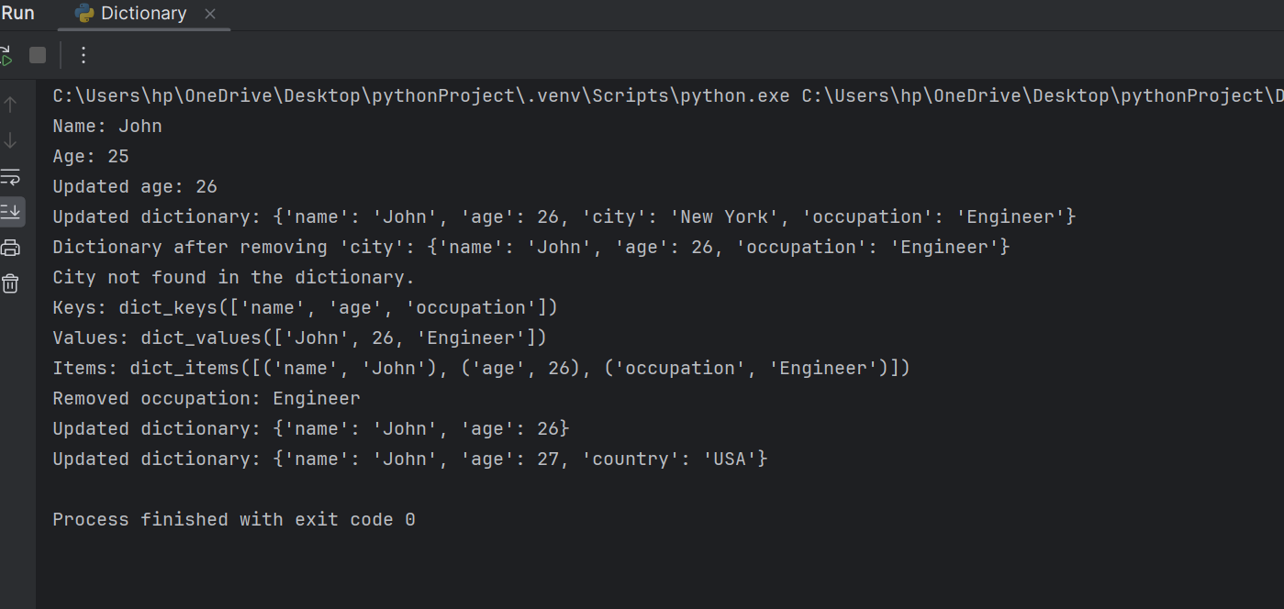

**MAPS**

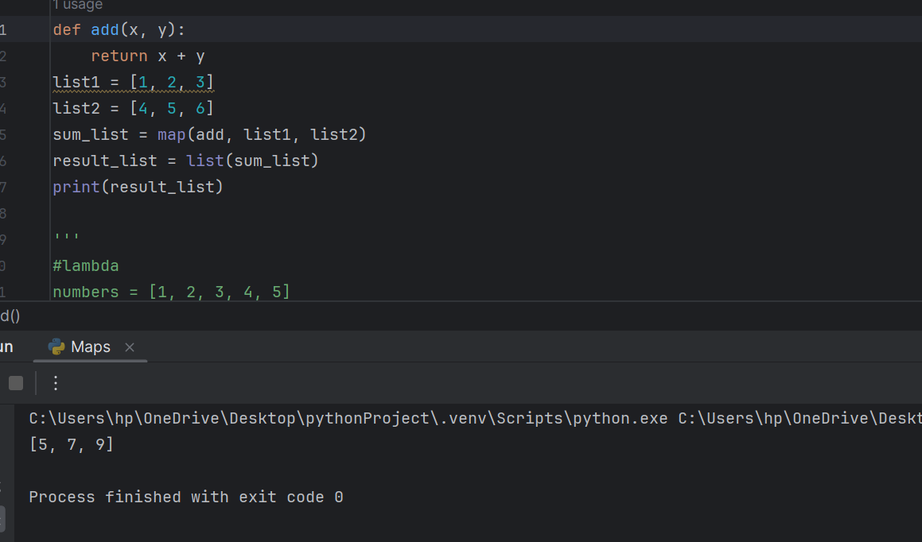

**Maps with Lambda and Filter:**

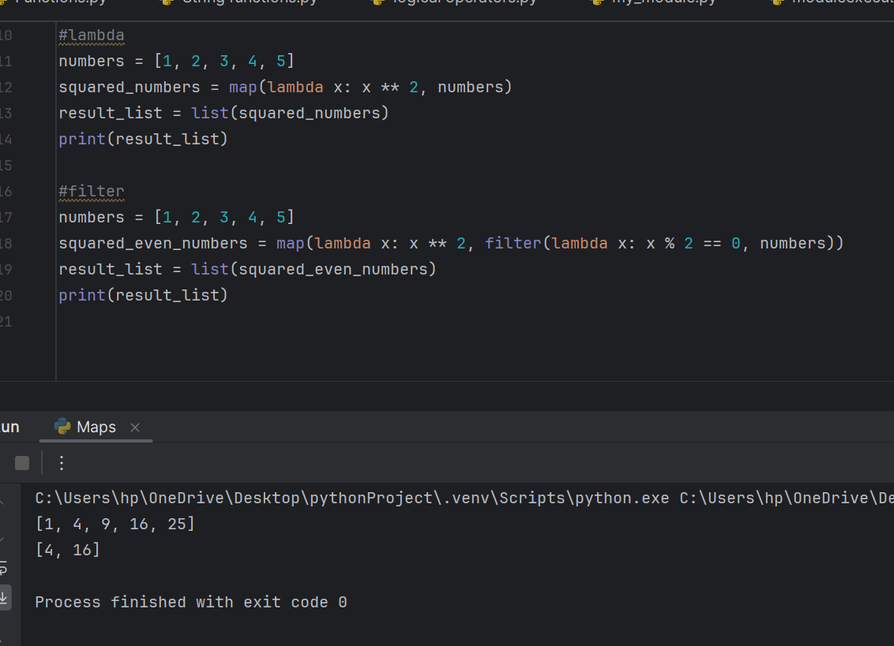

**Set And It’s Methods:**

my_set = {1, 2, 3, 4, 5}  
  
# Adding elements to the set  
my_set.add(6)  
my_set.update({7, 8, 9})  
print("Updated set:", my_set)  
  
# Removing elements from the set  
my_set.remove(3)  
print("Set after removing 3:", my_set)  
  
# Checking membership  
print("Is 5 in the set?", 5 in my_set)  
  
# Set operations  
set1 = {1, 2, 3, 4}  
set2 = {3, 4, 5, 6}  
  
# Union  
union_set = set1.union(set2)  
print("Union of sets:", union_set)  
  
# Intersection  
intersection_set = set1.intersection(set2)  
print("Intersection of sets:", intersection_set)  
  
# Difference  
difference_set = set1.difference(set2)  
print("Difference of sets:", difference_set)  
  
my_set.discard(2)  
print("Set after discarding 2:", my_set)

**Output:**

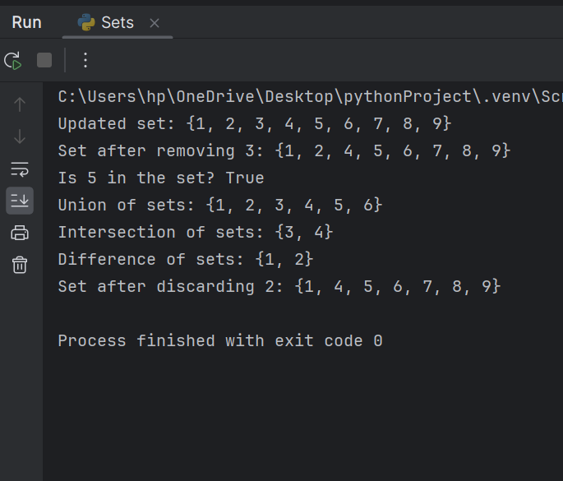

**And,or,not:**

# Example using 'and' operator  
x = 5  
y = 10  
  
if x > 0 and y > 0:  
 print("Both x and y are positive.")  
else:  
 print("At least one of x or y is not positive.")  
  
# Example using 'or' operator  
x = -5  
y = 10  
  
if x > 0 or y > 0:  
 print("At least one of x or y is positive.")  
else:  
 print("Neither x nor y is positive.")  
  
# Example using 'not' operator  
x = True  
if not x:  
 print("x is False.")  
else:  
 print("x is True.")

**Output:**

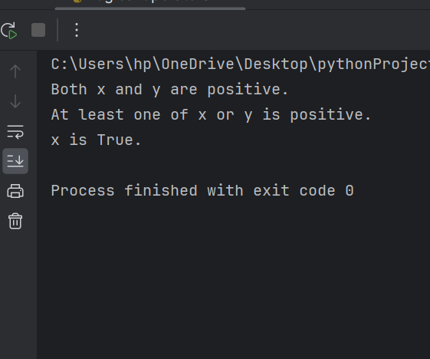

**String Functions:**

#capitalise  
text = "hello, world!"  
print(text.capitalize())  
#upper  
text = "hello, world!"  
print(text.upper())  
#lower  
text = "Hello, World!"  
print(text.lower())  
#replace  
text = "Hello, World!"  
new_text = text.replace("World", "Python")  
print(new_text)  
#strip  
text = " Hello, World! "  
stripped_text = text.strip()  
print(stripped_text)  
#split  
text = "apple,banana,orange"  
fruits = text.split(',')  
print(fruits)  
#join  
fruits = ['apple', 'banana', 'orange']  
text = ', '.join(fruits)  
print(text) # Output: 'apple, banana, orange'  
#count  
message = 'Have a Good Day'  
print('Number of occurrence of a:', message.count('a'))  
#find  
message = 'Have a Good Day'  
print(message.find('Day'))

**Output:**

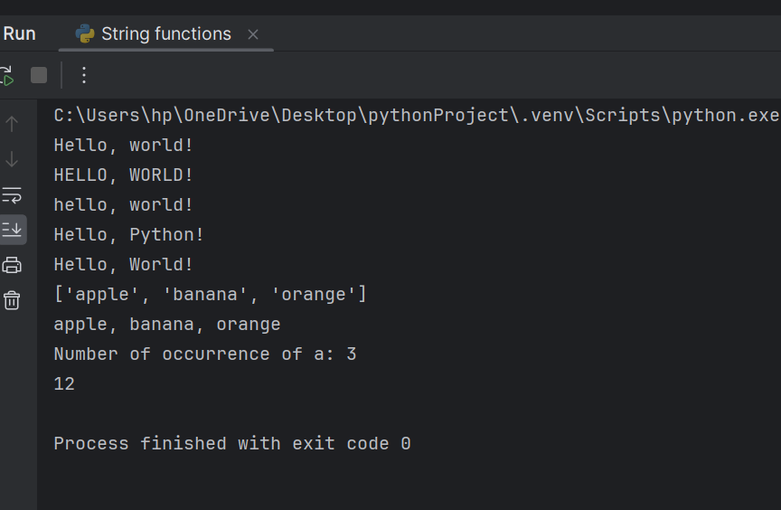

**Functions:**

def greet(name):  
 print(f"Hello, {name}!")  
greet("Alice")  
  
#function with parameters  
def add_numbers(a, b):  
 return a + b  
result = add_numbers(5, 3)  
print("Sum:", result)  
  
#default arguments  
def myFun(x, y=50):  
 print("x: ", x)  
 print("y: ", y)  
  
#Keyword Arguments  
def student(firstname, lastname):  
 print(firstname, lastname)  
student(firstname='Hexa', lastname='Practice')  
student(lastname='Practice', firstname='Hexa')  
  
#variable-length arguments  
def print_args(*args, **kwargs):  
 print("Positional arguments:", args)  
 print("Keyword arguments:", kwargs)  
  
print_args(1, 2, 3, name="John", age=25)  
  
  
# Positional argument  
def nameAge(name, age):  
 print("Hi, I am", name)  
 print("My age is ", age)  
print("Case-1:")  
nameAge("Suraj", 27)  
# You will get incorrect output because  
# argument is not in order  
print("\nCase-2:")  
nameAge(27, "Suraj")  
  
#use of docstring  
def evenOdd(x):  
 if (x % 2 == 0):  
 print("even")  
 else:  
 print("odd")  
print(evenOdd.__doc__)

**Output:**

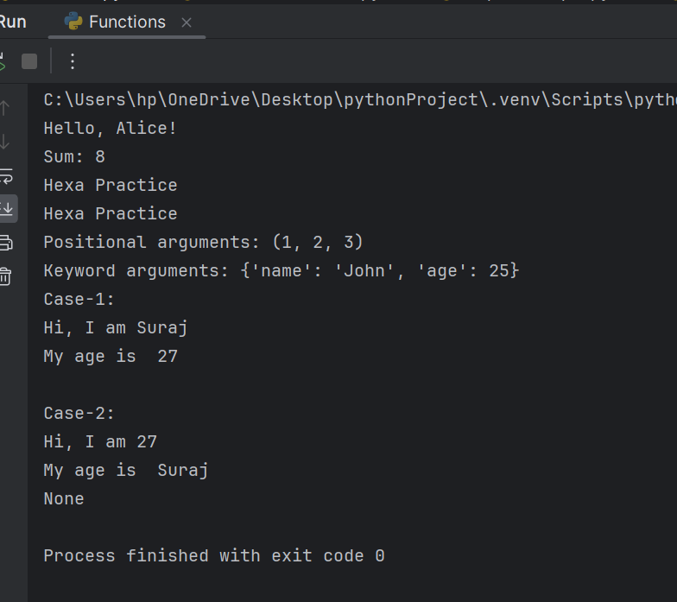

**Method Overloading**

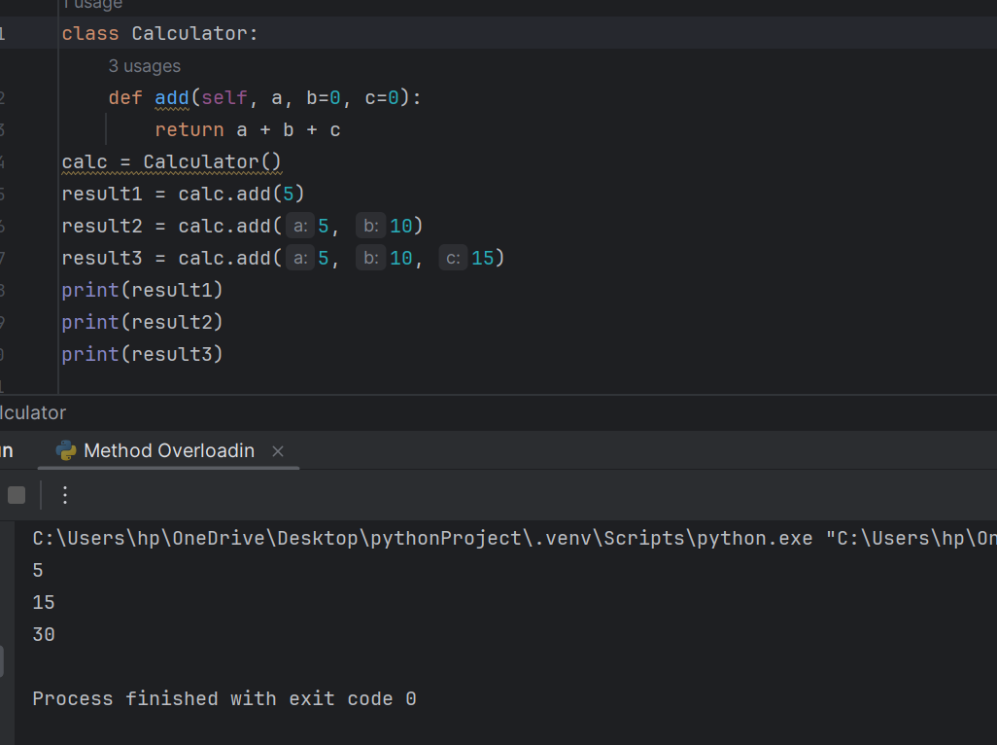

**Oops Concepts:**

#Encapsulation  
class Car:  
 def __init__(self, model, color):  
 self.model = model  
 self.color = color  
  
 def display_info(self):  
 print(f"Model: {self.model}, Color: {self.color}")  
  
my_car = Car("Toyota", "Blue")  
my_car.display_info()  
#Inheritance  
class Animal:  
 def __init__(self, name):  
 self.name = name  
  
class Dog(Animal):  
 def bark(self):  
 print("Woof!")  
  
my_dog = Dog("Buddy")  
print(my_dog.name)  
my_dog.bark()  
#polymorphism  
class Bird:  
 def make_sound(self):  
 pass  
  
class Sparrow(Bird):  
 def make_sound(self):  
 print("Chirp chirp!")  
  
class Crow(Bird):  
 def make_sound(self):  
 print("Caw caw!")  
  
def make_bird_sound(bird):  
 bird.make_sound()  
  
sparrow = Sparrow()  
crow = Crow()  
  
make_bird_sound(sparrow)  
make_bird_sound(crow)  
  
#Abstraction  
from abc import ABC, abstractmethod  
  
class Shape(ABC):  
 @abstractmethod  
 def area(self):  
 pass  
  
class Circle(Shape):  
 def __init__(self, radius):  
 self.radius = radius  
  
 def area(self):  
 return 3.14 * self.radius * self.radius  
  
circle = Circle(5)  
print(circle.area())

**Output:**

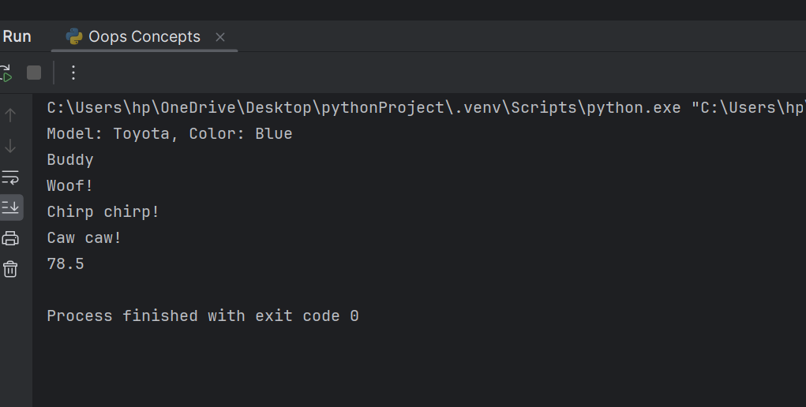

**Modules**

